SETTING THE SOFTWARE
The generator has a standard communication interface ModBus RTU over RS 485. To connect to a PC you should use MPI adapter USB or RS 232 to RS 485 optically isolated.

Before starting the software for the generator, you need to follow and execute the following steps

Install the software in the sequence as follows:

- Unzip “Sonoweld DDS Installer 18042020.zip”
- Run : “ setup “ from Sonoweld DDS Installer 18042020\Volume. This will install LabView control software on your computer.
- Run: ”CDM+v2.12.36.1+WHQL+Certified.zip”, or “CDM 2.04.06” from Sonoweld DDS Installer 18042020\ . This will install USB to RS485 driver. Find latest USB to RS485 driver here: https://ftdichip.com/drivers/vcp-drivers/
Now you are ready to start the executable file, “sonoweld DDS.exe”, of the software of your generator.
- First action (regarding all generators and all software we are offering), after activating specific generator software, is to connect your PC with ultrasonic generator using our RS485-USB adapter.
- Then you need to select and activate proper operating COM port from the generator software tabs. This will open communication between your PC and your ultrasonic generator.
- Then you need to select initial setting conditions regarding expected frequency range.
- Then you need to make Scanning to see where ultrasonic load is able to operate.

ADJUSTING THE GENERATOR USING THE PC SOFTWARE

COM Tab
Start with COMM tab, and select proper COM port.
NOTE: Every new generator has 5 modbus address by default.
To connect the generator to the labview software we need to cover the following three conditions:
To know the Modbus address of the generator. Every new generator has 6 modbus address by default.
To know the exact COM port where the USB to RS485 driver is installed. Go to the Device Manager of your PC and find the USB Serial Port(The USB adapter must be plugged to one of the USB ports of your PC).
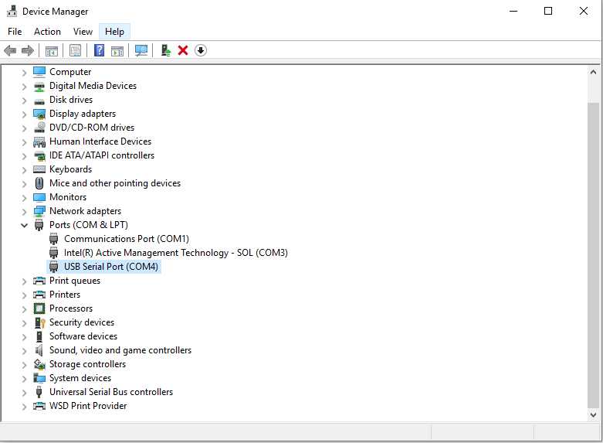

To set the correct communication baud rate.
At this moment you will have NO connection (initialized in red on top of the window)(2).
After validating the com port you will have connection (initialized in lime green on top of the window).
4. Select the ModBus address of the generator you want to connect to. Every new generator has default ModBus address 6.
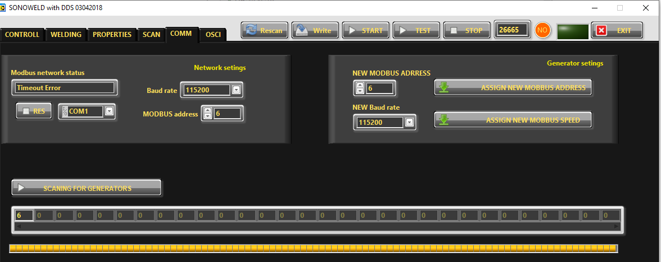
Press “SCANNING FOR GENERATORS”. After scanning (the yellow bar will become full in a few seconds), you will find the address (es) of the available generator(s) you will drive . Check if the value of the address in “MODBUS address” field is correct and if needed change it with the value shown in the table below the button “SCANNING FOR GENERATORS”. Beat counter will become alive and will start changing the figures. Connection (lime-green) light should be active. Now you are connected to the generator with the selected address.
NOTE: Every new generator has 6 ModBus address by default.

